EECS332 Digital Image Analysis
MP6 – Mikhail Todes

For this MP, I decided to switch from c++ to using MATLAB. This was mainly because of the ease of use of MATLAB.

My code runs through the following steps:

- First an edge detector algorithm is run.
- Then the parameter space is found .
- From here the significant intersections are found .
- Finally the lines are detected and drawn.

For the edge detection, the canny method was used. Each of the edges coordinates are stored as an x and y position. Next the parameter space is made. The coordinates are converted to their polar coordinates and checked for validity. Then there is a voting procedure where the vote is where the difference between temp and rho is equal to the min value of the difference. All the results that are not within the desired threshold or that have a zero are discarded.

The parameter space is plotted with the found Rho values on the X-axis and the found Theta values on the Y-axis.

Finally the lines are plotted according the the equation y = mx + c.

The program was tested for all three given test images and with different parameter values. The best thresholds found were:
- 77 for test.bmp, ts = rs = 1.
- 89 for test2.bmp, ts = rs = 1.
- 56 for input.bmp, ts = rs = 1.

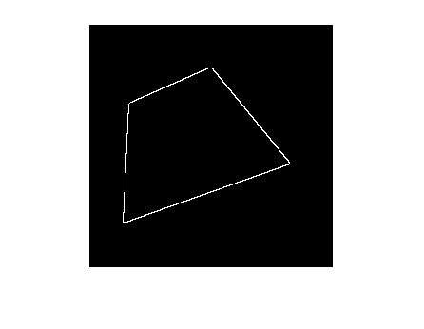Illustration 2: Edge Detection test.bmp
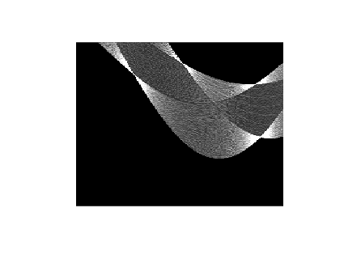Illustration 1: Parameter Space test.bmp
Illustration 5: Edge Detection test2.bmp
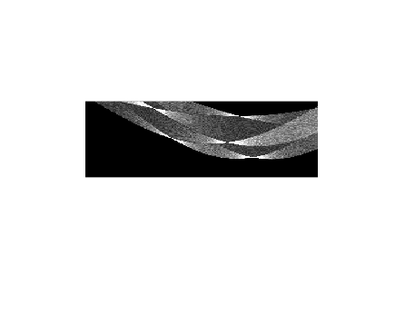Illustration 3: Parameter Space test2.bmp
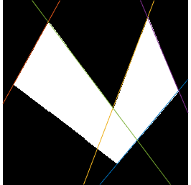Illustration 4: Hough Lines test2.bmp
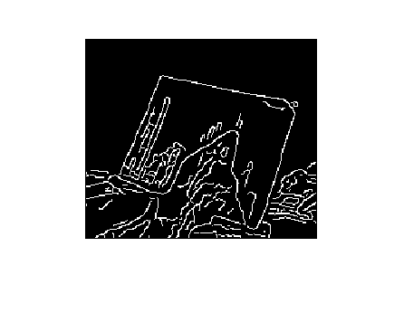Illustration 6: Edge Detection input.bmp
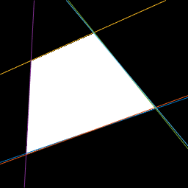Illustration 7: Hough Lines test.bmp

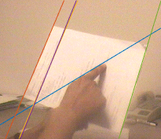Illustration 8: Hough Lines input.bmp
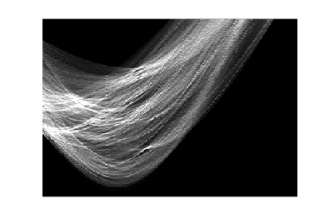Illustration 9: Parameter Space input.bmp

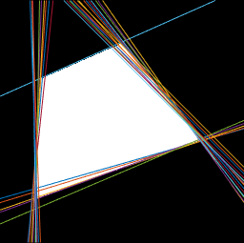Illustration 10: Threshold of 20
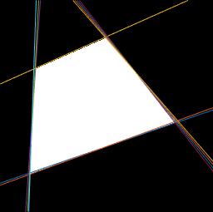Illustration 11: Threshold of 50
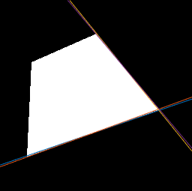Illustration 12: Threshold of 90
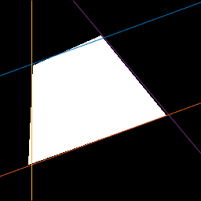Illustration 13: ts = rs = 10
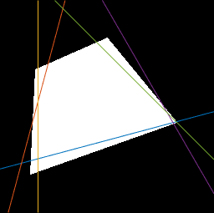Illustration 14: ts = rs = 15
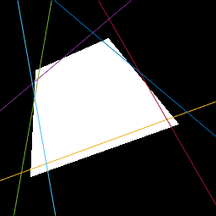Illustration 15: ts = rs = 20
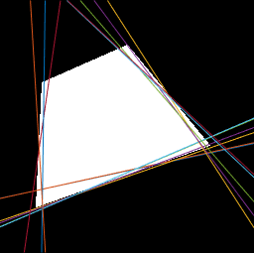Illustration 16: ts = 0.2, rs = 15

